**Entrepreneurs Growth Alliance™ - Cohort 2401**

**Learnings Covered in Teaching Session on 09/19/2024:**

**BONUS SESSION: Crucial for Hiring the Right Talent**

* **Hiring Process**: We discussed the importance of creating a clear and detailed job description before starting the hiring process to clarify the role's responsibilities.
* **3D Job Description**: A method was introduced to build a "3D" job description that outlines crucial responsibilities, required skills, and the ideal personality traits for the role.
* **Team Insights**: We encouraged team members to share their hiring experiences, providing valuable perspectives to improve the process.

**Topics To Be Covered in the Next Teaching Session on 09/26/2024:**

**Binder Information – Tab Four: Continuation**

1. We’ll discuss **1-year and 3-year strategic planning, take a live example of Luis InTech,** and review it.
2. **GRPI Tool:**

Raj will introduce the GRPI Tool, a robust framework to help align your team for success. GRPI stands for:

* Goals: Are your team’s objectives clear and aligned?
* Roles: Does everyone understand their responsibilities?
* Processes: Are there efficient systems in place to get things done?
* Interpersonal Relationships: How strong is the trust and communication within your team?

We’ll explore how GRPI helps avoid confusion, streamline efforts, and improve team dynamics.

### **2. Communication Plan:**

Effective communication is critical to any successful project, and in this session, Raj will walk you through creating a solid Communication Plan. This will help ensure everyone is on the same page, with consistent messaging across your team and organization. We’ll focus on:

* Setting the right communication frequency and channels.
* Identifying key stakeholders who need to be kept in the loop.
* Ensuring alignment with your business vision in every communication.

**Zoom Meeting Link for the Next Teaching Session (09/26/2024 11 AM EST):**

**EGA Cohort 2401 – Teaching Sessions**

<https://us02web.zoom.us/j/89213327737?pwd=VNeOFZbau9WNgSQRRzL5vNMac7UP5I.1>

**Tomorrow (Saturday) Coaching Session (i.e., Q&A Session) on 09/21/2024:**

* This is not a teaching session; it's an interactive Q&A session focused on your previous learning and execution.
* Reflect on what you've learned, and be prepared to ask and discuss your questions.
* Based on your reading, come up with at least three (3) questions to discuss during the session.

**Zoom Meeting Link for the Tomorrow’s Coaching Session (i.e., Q&A Session) on 09/21/2024:**

[**https://us02web.zoom.us/j/82881106686?pwd=XlLayU1bpZNizxUEw3bgek98t6EoMD.1**](https://us02web.zoom.us/j/82881106686?pwd=XlLayU1bpZNizxUEw3bgek98t6EoMD.1)



**Key Insights And Homework Ideas To Reflect On And Master The Concepts:**

1. **Submit Job Descriptions or Current Responsibilities:**

All participants are required to submit their job descriptions or a detailed list of their current responsibilities to Kumar by September 20th. This will ensure we clearly understand your roles within your organization.

1. **Complete a Sample Project Charter:**

All leaders must complete at least one sample project charter by September 21st. This exercise will help reinforce the project management principles discussed during the sessions.

1. **Review and Answer Strategic Questions:**

(Please refer to the Tab 4, Page 81, Generate Box-3 Ideas)

Before the upcoming Saturday session, please review and respond to the five strategic questions concerning customer discontinuities, technology shifts, non-traditional competitors, and other relevant factors. Your answers will form the basis of our strategic planning discussions.

1. Please come up with your company's vision, purpose, core values, accountability, and norms.

**Note:** **Very Important**

* **Schedule a One-On-One Session: Please schedule individual meetings with Rajesh and Kumar to discuss your assessments and homework and review the topics covered**. After September 9th, 2024, email us your available time slots at **Akumar@vrt9.com** to confirm your session.
* Please submit all your questions before the Coaching Session (Q&A session) on 09/21/2024. This will ensure we have a practical discussion and maximize our learning experience.

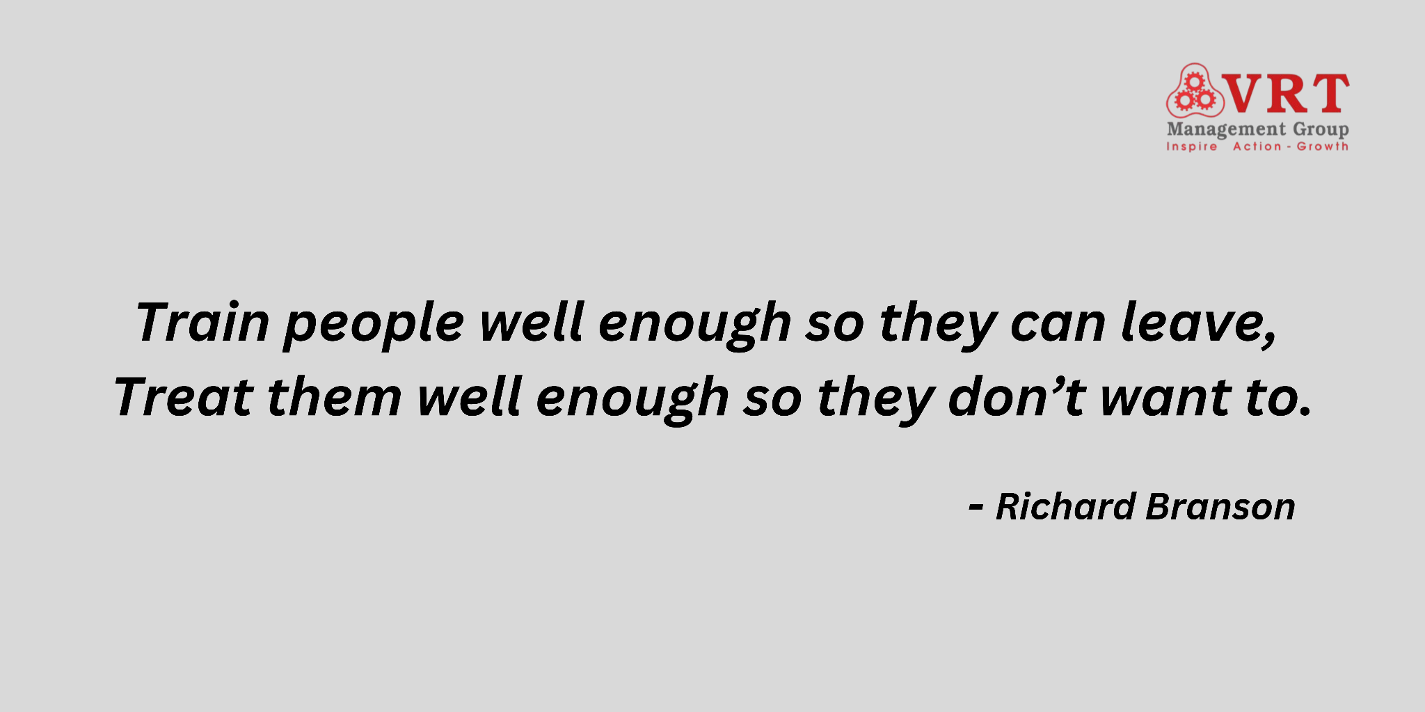

**--- END ---**